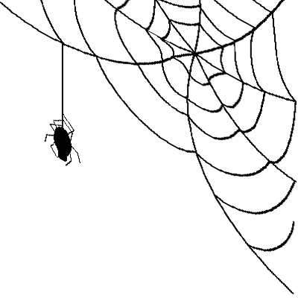
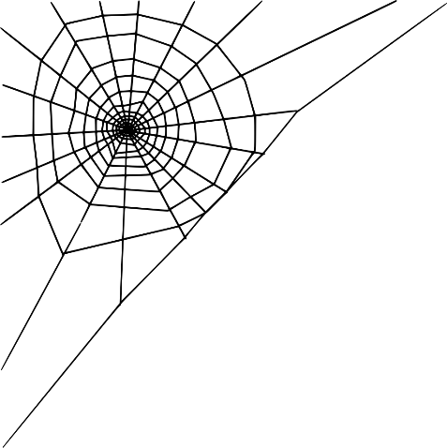
✨ The Laurel Academy ✨
This Photo by Unknown Author is licensed under CC BY-NC
✨Defence again the Dart Web✨

Welcome, aspiring wizard! Today you will be taking your first steps into the magic of Computer Science and IT. Follow the instructions below to complete your O.W.L. examinations and code your very own wand selector.

🎩 Activity 1: The Sorting Hat (Python & micro:bit)
Try the sorting hat, a tap of the wand will decide where you truly belong.
Then it’s time to create your own.
- Head over to the hardware station with the micro:bits.
- Take a look at the Python script on the screen. It uses a random module to select a destiny!
- Follow the instructions card to download the code to the micro:bit.
- Shake the micro:bit to trigger the Sorting Hat algorithm and watch the LED screen.
The Sorting Hat has placed me in: ____________________________________________________

🗺️ Activity 2: Mischief Managed Cryptography
The Marauders have hidden their secrets using an ancient cipher.
- Locate the locked parchment on the cryptography desk.
- The message has been scrambled using a Caesar Cipher.
- Use the cipher wheel or the decryption key provided at the station to shift the letters back to their true meaning.
What is the hidden password to unlock the map? _________________________________
📜 Activity 3 The O.W.L. Typing Exam
Before you can cast spells, you must prove your wand control!
- Go to the Computing Launchpad and click O.W.L. Typing Exam.
- Enter your name and click 📜 Prepare Scroll.
- Type the magical incantation exactly as it appears. Fix any mistakes as you go!
- Record your final scores below:
- My Typing Speed: _______ WPM
- My Spell Accuracy: _______ %
(Did you make the Top 10 Highscore Leaderboard? Check the big screen!)
🪄 Activity 4: Ollivanders' Wand Selector
Every wizard needs a wand. Let's use HTML, CSS, and JavaScript to code your own.
- Go back to the Computing Launchpad and click 🪄 Wand Selector.
- Click the 💻 Open Code Editor button in the bottom right corner.
- Scroll through the code to find the STUDENT TASKS and make the following changes:
Task 1: House Colors (CSS) Find STUDENT TASK 1 in the code. Change the background-color to match your Hogwarts House!
- 🦁 Gryffindor: #740001
- 🐍 Slytherin: #1A472A
- 🦅 Ravenclaw: #0E1A40
- 🦡 Hufflepuff: #EEB939
Task 2: Frame Your Magic (CSS) Find STUDENT TASK 2. Change the border thickness (e.g., to 10px) or try changing the colour!
Task 3: Change the crest to match your house colour (HTML) Find STUDENT TASK 3 (scroll down!). Change the name of the image source file (src=””) to match you chosen crest.
- hogwarts.png
- gryffindor.png
- slytherin.png
- ravenclaw.png
- hufflepuff.png
Task 4: Discover New Woods (HTML) Find STUDENT TASK 4 (scroll down!). Add two new types of wood to the woods array.
Hint: Use the html open and close tags to define the drop down list item
<option value="Birch">Birch</option>
Task 5: A Custom Message (JavaScript) Find STUDENT TASK 5. Change the message Ollivander says when your wand is chosen!
Hint: Change the line text in the speech marks on this line to customize the message.
let message = "Curious... very curious. Your perfect match is "
When you have finished coding, click ▶ Run Code in the editor. Choose your preferred core and flexibility from the drop-down menus, and click Find My Wand to see your creation come to life.
My perfect wand is:
__________________________________________________________________
Check the Live Dashboard to see your wand added to the academy's official magical ledger!
🏆 Graduation! - ⚡ Mischief Managed! ⚡

